Tax Declarations for 2025

Tax documents/Declarations
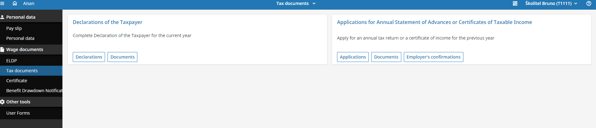
I will create NEW RECORD and confirm
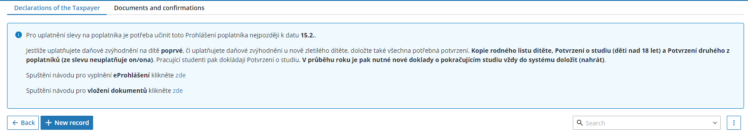
Confirm the date from January 2025 and go to the next step
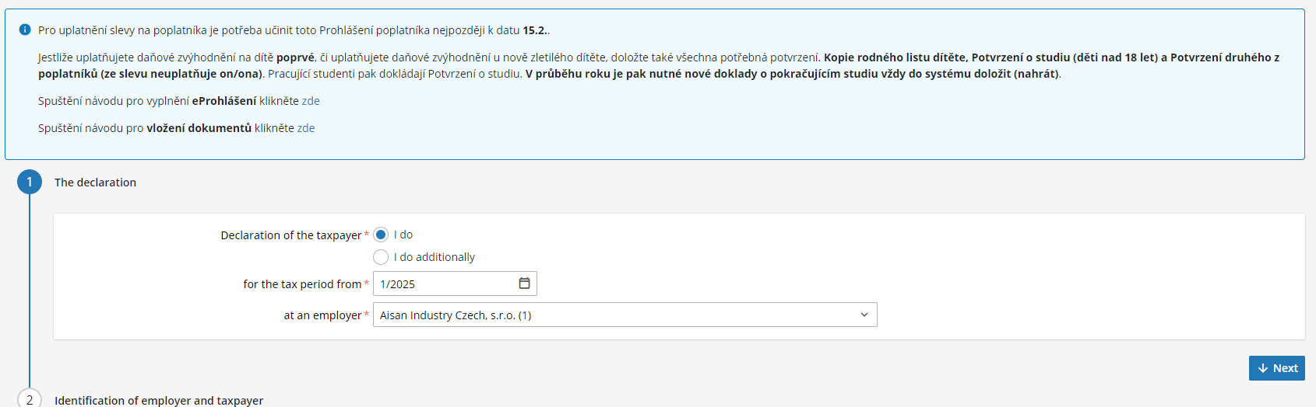
Confirm the validity of your personal data and go to the next step
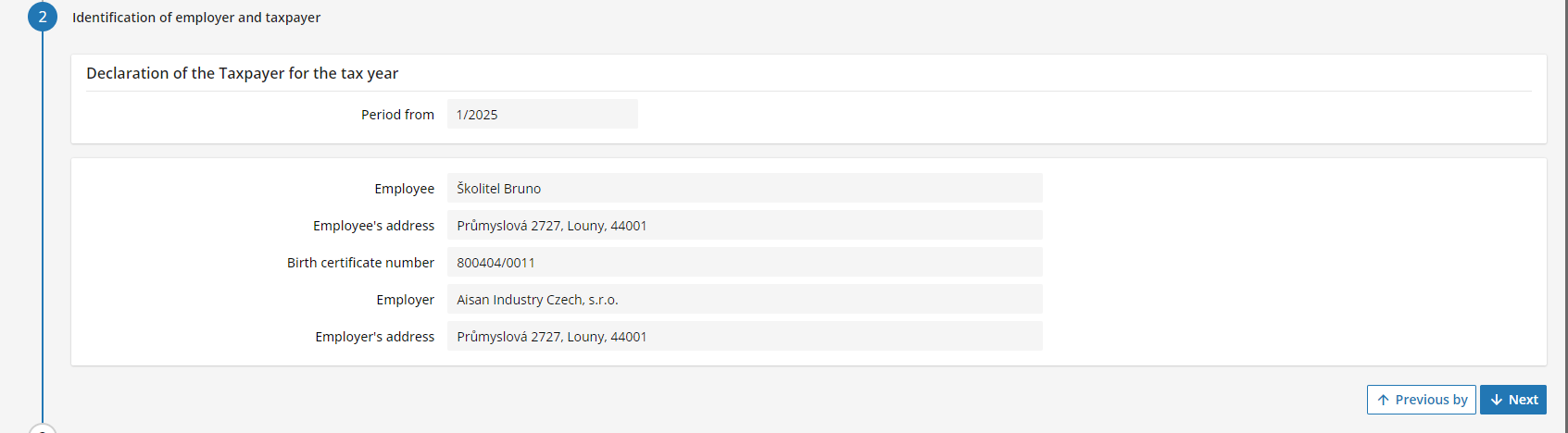
Confirm your residency in the Czech Republic and go to the next step
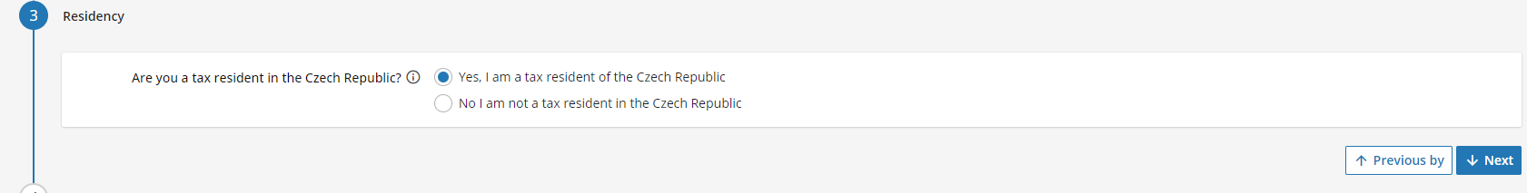
Apply the tax deductions and go to the next step
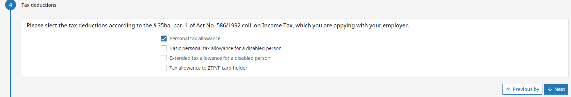
Confirm if you have kids (in case you already had tax benefit for your kids it will be filled) – you can go to the next step
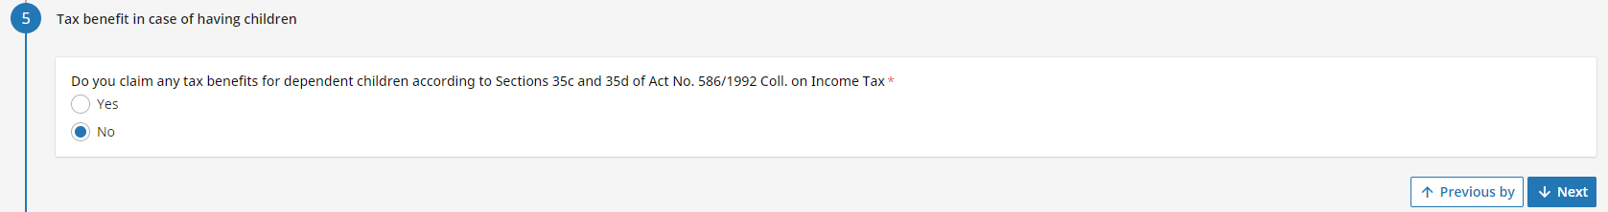
Confirm your authorisations and go to the next step
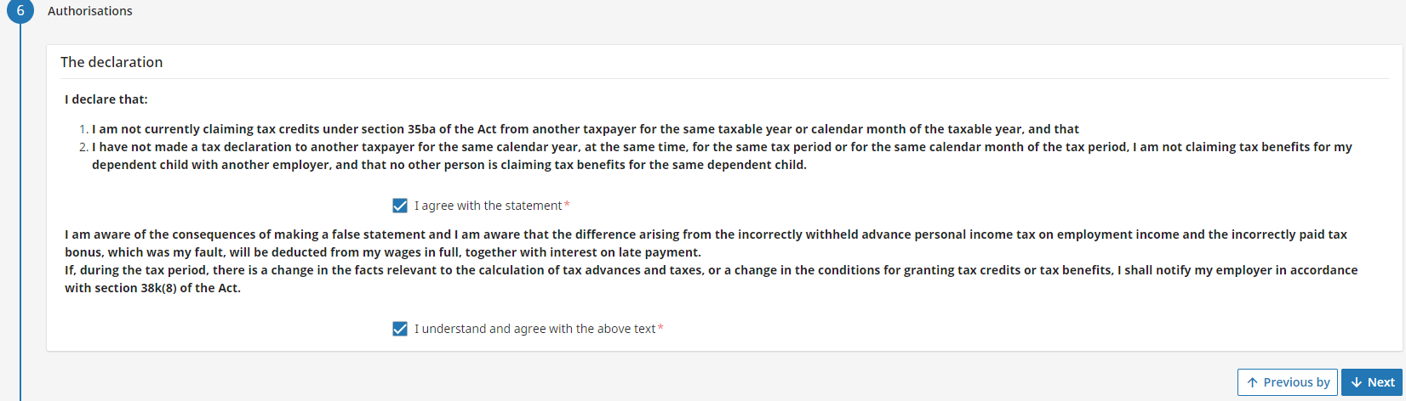
Submit

